Attempted Reform in Faltering Soviet Union (1990): Economic and social reforms designed to reverse decline of USSR backfire. As the USSR continued its slide, individual republics within the Soviet Union begin to withhold tax revenues, seriously undermining central control.

Break-Away Soviet Republics (1990): The central Soviet Union government was forced to allow more autonomy to the individual republics. Republics such as Lithuania, Latvia and Estonia assert independence from the USSR.

Newly-Independent Soviet Republics Transition to Democracy and European Integration (1990-91): Several Eastern European nations were liberated upon the collapse of the Soviet Union, enabling them to democratise and become integrated with the rest of Europe, leading to a more influential and consolidated European Union.

Each former Soviet Republic in Eastern Europe elected for an independent and democratic government. Newly-independent republics included Estonia, Latvia, Lithuania, Belarus, Ukraine, Moldova, Czechoslovakia and Russian Federation (the dominant republic in the former USSR).

Soviet Military Response to Break-Away Republics (1991): The Soviet Army attempted to suppress independence movements, but this further damaged Soviet authority, creating a public relations backlash.

Attempted Coup within Soviet Union (1991): Most soviet republics were in favour of maintaining the Soviet Union, but with greater decentralisation and local autonomy. Key members of Gorbachev's cabinet were appalled by the weakening of central authority, and staged a coup, placing Gorbachev under house arrest, and hoping to rally public support in their favour.
Popular opinion was largely against the hard-line coup and protests began. The coup organisers were forced to surrender. Despite returning to office as Head of State, Gorbachev was now impotent as a leader, as his leadership had been completely undermined.

Dismantling of the USSR (1991): After the failed coup, individual republics began to operate with complete autonomy, taking possession of Soviet property on their territory. The USSR recognised independence of the three Baltic states (Lithuania, Latvia, Estonia). When Russian President Yelstin moved to disband the Soviet Union, removing Gorbachev from power, he was largely supported by the Russian populace. Ukraine and Belarus also supported the move. Only 5 of the 15 republics signed off on this.

Official Dissolution of the USSR (1991): After all the republics had ratified the dissolution of the Soviet Union in December, Gorbachev resigned, acknowledging the end of the union.

Beginning of Yugoslavia Wars (1991): Began with demonstrations in Kosovo (region within Serbia) by Albanians, which resulted in counter demonstrations by Kosovo Serbs, a minority in Kosovo. Serbs were the dominant ethnic group within Yugoslavia throughout its history. The Serb-dominated Yugoslavian government simply took the side of the Serbs. Finding continued Serb dominance and oppression unacceptable, Slovenia, Croatia, Macedonia and Bosnia & Herzegovina separated from Yugoslavia, claiming independence. Serbia became Serbia and Montenegro (named the Federal Republic of Yugoslavia). Serbia encouraged Serb revolts within these newly-claimed independent regions.

Reasons for Yugoslavia's Collapse
- Economic Issues: After the fall of the USSR, western nations, including the U.S., implemented trade barriers against Yugoslavia, which still had a communist government. During the Cold War, Yugoslavia refused to ally with the Soviet Union, inviting concessions from western nations, in hopes of keeping Yugoslavia out from under Soviet influence and control. Without this incentive, western nations became economically hostile toward Yugoslavia, badly damaging the once thriving economy.

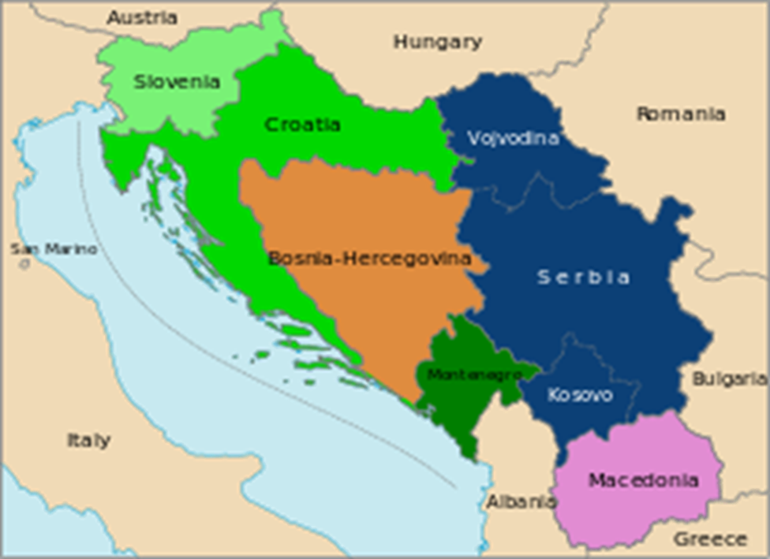

2. Ethnic Divides: Yugoslavia is comprised of several ethnic groups which only consolidated into a unified nation after WWI. Serbia had long been the dominant South Slav ethnic group and continued to assert itself as the dominant partner in the nation of Yugoslavia. Serb-biased policy sparked ethnic tensions within Yugoslavia, which became especially evident with the falling economy.

3. Increased Autonomy for Ethnic Groups: By the early 1990s, most ethnic groups demanded increased autonomy, in response to Serb domination. The Serbia-dominant government was forced to concede. Increased autonomy led to demands for independence. Serbs then fought fiercely to maintain centralised rule over its fellow South Slav brethren.

10-Day War in Slovenia - Part of Yugoslavia Wars (1991): First armed conflict in Yugoslav Wars is between the Serb-controlled federal army and the Slovenes. Slovenes withstood the Serbs, ensuring independence.

Independence from Yugoslavia for Macedonia (1991): Macedonia's declaration of independence unchallenged by Yugoslavia. In 2001, ethnic Albanians attempt to carve out an Albanian nation within Macedonia, potentially to be combined with Albanian-dominated Kosovo. Macedonia's army successfully extinguished the threat.

Croatian War of Independence - Part of Yugoslavia Wars (1991-95): Croatian declaration of independence invited an armed response by the Yugoslavian Army from Serbia and ethnic Serbs inside Croatia. Atrocities against civilians were committed by both sides. Croatia secured independence in the conflict. UN troops were sent in to protect Serb populations.

Bosnian War of Independence - Part of Yugoslavia Wars (1992-95): The war spread to Bosnia in 1992, the bloodiest and most covered part of Yugoslavia Wars. It staged the Bosnian Muslims against the Bosnian Serbs. The Bosnian Croats fought against the Serbs as well, but also fought against the Muslims on occasion. Atrocities werre committed by all sides, but Bosnian Muslims were victimised the most, and a large number of Muslim civilians were killed by Bosnian Serbs. The UN and NATO also participated at various times, often switching sides. In 1995, the international-brokered end to the war established an independent Bosnia & Herzegovina, the most ethnically-mixed of all the former-Yugoslavia nations. Croat, Serb, Muslim and mixed zones were established to ensure fair representation for all sects.

Russian Constitutional Crisis (1993): The Parliament opposed Yelstin’s rapid privatisation policies (termed "shock therapy"). They voted to depose Yelstin as President of Russia, but Yelstin called in the special forces to have dissenting Parliamentary members detained, resulting in riots. Yeltsin managed to maintain power, but Parliament no longer was seen as relevant, as Yelstin used the incident to push through a new constitution dictating a much stronger office of presidency, and a diminished Parliament.

European Union Established (1993): The removal of the iron curtain allowed for cooperation among all European states. Eastern states were able to be connected with the western world, opening up new opportunities for commerce and diplomacy. The larger objective for the EU was to avoid continental wars that had been historically endemic and catastrophic.
The Cold War represented another potential great war, so with the end of this threat, European nations aimed for closer cooperation and integration, to prevent tensions that led to wide-spread war throughout the continent in the past. European states also realised other potential benefits of increased cohesion. Europe had long been a continent subdivided among several nations, as opposed to Russia and the United States (and now emerging China), which are massive, consolidated states, bringing populations far greater than that of any single European state under one banner. The EU now represented a way for Europeans to potentially compete more directly with such super powers.

Split-Up of Czechoslovakia (1993): After attaining complete sovereignty as a nation with the collapse of the Soviet Union, Slovaks in Czechoslovakia called for greater autonomy in the Czech-led nation. This resulted in the peaceful split of the nation into the Czech Republic and the Republic of Slovakia.

First Chechen War (1994-96): When the Russian republic of Chechnya attempted to break away from the Federation, Russia mobilised its army to assert control. Chechen rebels waged a guerrilla war, which turned public opinion against the war in Russia, forcing Russia to withdraw and cede de-facto independence to Chechnya in 1996.

Russian Financial Crisis (1998): The global recession of 1998 was especially damaging for Russia, whose economy was/is dependent upon the export of raw materials. Russia would experience a financial collapse, as the government became unable to collect enough tax revenues to pay off loans and to pay its employees. The economy recovered very quickly in 1999 and 2000, as energy costs skyrocketed, resulting in a large trade surplus and cash reserve.

Kosovo War - Part of Yugoslavia Wars (1998-99): The majority ethnic-Albanians in the region of Kosovo begin a separatist movement against Yugoslavia. Serbia sent troops into Kosovo to re-assert control. After evidence of brutal civilian killings were uncovered, NATO undertook a bombing campaign against Serbia to force it to withdraw, which it did in 1999.

Vladimir Putin Rises to Russian Presidency (1999): Vladimir Putin was appointed president by Boris Yeltsin, who resigned his post. This placed Putin as the frontrunner for the 2000 elections, in which he achieved victory. Putin would be fortunate to serve during a time of strong economic growth in Russia, primarily due to rising global energy prices, upon which Russia is highly dependent as a major energy producer. Putin would take a strong stance against the oligarchs (entrepreneurs that took advantage of the rapid privatisation after the USSR collapsed, collecting massive assets, becoming extraordinarily wealthy, yet hated). Putin had many imprisoned and exiled, with the state taking possession of their assets. Putin has also attempted to reassert Russian dominance in former bloc countries such as Belarus and Ukraine, an effort which has been fairly successful by withholding desperately-needed natural gas from Europe.

Second Chechen War (1999-Present): In 1999, Chechen militants carried out multiple invasions and terrorist acts into Russia, eliciting an invasion by Russia into Chechnya. By 2000, Russia had reasserted control over Chechnya, but the conflict persists as rebels continue to wage guerrilla war against Russia's army units.

Sept. 11 Attacks in U.S. (2001): Fanatical Muslims hijacked four commercial air planes, flying two into the World Trade Centre Twin Towers in New York City, and one into the Pentagon in Washington. The fourth was overrun by passengers, and failed to reach its intended target of the Capitol Building in DC, crashing in Pennsylvania.

Note: 9-11 Effect on Europe. The attacks propelled the U.S. into a "War on Terrorism", which would have impact on Europe, drawing several European nations into cooperation with the U.S.-led campaign against fanatical Islamic groups throughout the world, such as al-Qaeda. The primary theatres would be Iraq and Afghanistan, both pre-emptively invaded by the U.S.-dominated coalition, but with the support of several European nations. European nations such as the UK and Spain would experienced Islamic-motivated terrorist attacks on their own soil in retaliation for their part in the war.

